ID:N210264
NAME:Alapati.Sree Harsha
ROLL-NO:22
LAB-03
Verification of Ripple Carry Adder and Carry-look-ahead Adder
Ripple Carry Adder
Description:
The Ripple Carry Adder (RCA) is a simple adder circuit that performs binary addition. It propagates the carry bit sequentially from one stage to the next, hence the name "ripple carry."
Circuit:
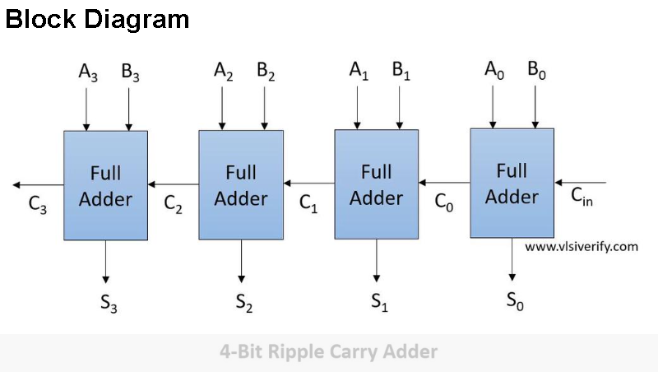

Truth Table:
A | B | Cin | Sum | Cout
0 | 0 | 0 | 0 | 0
0 | 0 | 1 | 1 | 0
0 | 1 | 0 | 1 | 0
0 | 1 | 1 | 0 | 1
1 | 0 | 0 | 1 | 0
1 | 0 | 1 | 0 | 1
1 | 1 | 0 | 0 | 1
1 | 1 | 1 | 1 | 1
Components Required:
- Multisim
- Probes
- Interactive Digital Constants
- Logic ICs (7486, 7408, 7432, 7404)
- Power Supply
Multisim Circuit:
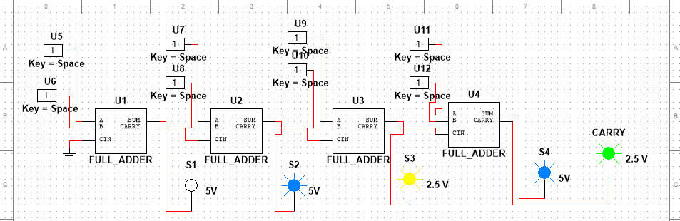

Procedure:
1. Connect the components on the Multisim as per the circuit diagram.
2. Power the circuit and verify its functionality using the truth table.
3. Use Multisim to simulate and validate the results.
Carry-look-ahead Adder
Description:
The Carry-look-ahead Adder (CLA) is a high-speed adder circuit that reduces the carry propagation delay by generating the carry signals in advance using logic equations.
Circuit:
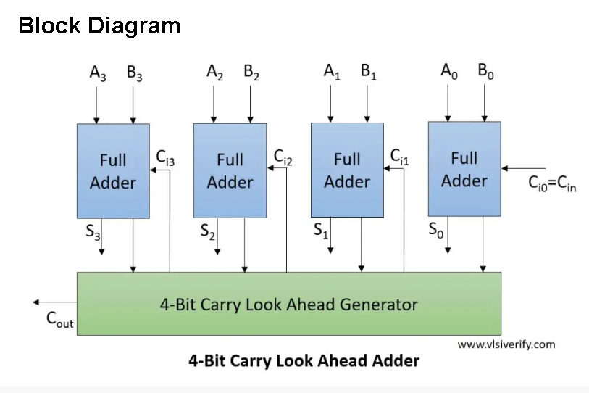
Truth Table:
A | B | Cin | Sum | Cout
0 | 0 | 0 | 0 | 0
0 | 0 | 1 | 1 | 0
0 | 1 | 0 | 1 | 0
0 | 1 | 1 | 0 | 1
1 | 0 | 0 | 1 | 0
1 | 0 | 1 | 0 | 1
1 | 1 | 0 | 0 | 1
1 | 1 | 1 | 1 | 1
Components Required:
- Multisim
- Probes
- Interactive Digital Constants
- Logic ICs (7486, 7408, 7432, 7404)
- Power Supply
Multisim Circuit:
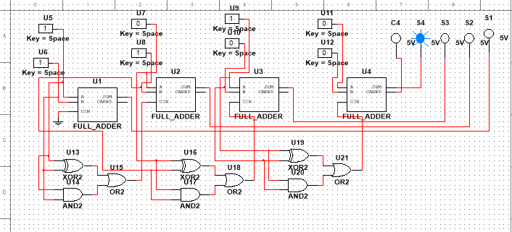

Procedure:
1. Connect the components on the Multisim as per the circuit diagram.
2. Power the circuit and verify its functionality using the truth table.
3. Use Multisim to simulate and validate the results.
Comparison of Ripple Carry Adder and Carry-look-ahead Adder
Feature | Ripple Carry Adder | Carry-look-ahead Adder
Design | Simple | Complex
Carry Propagation Delay | High (Sequential Propagation) | Low (Parallel Carry Generation)
Complexity | Low | High
Speed | Slow | Fast

